## Network and firewall configuration 1.1.4a / 1.1.5a, 1.2.1b

### Basic firewall diagram

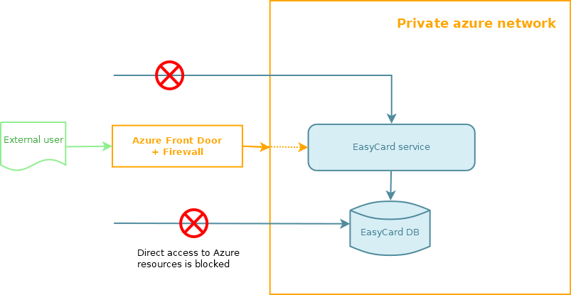

### Example of access restriction for app service

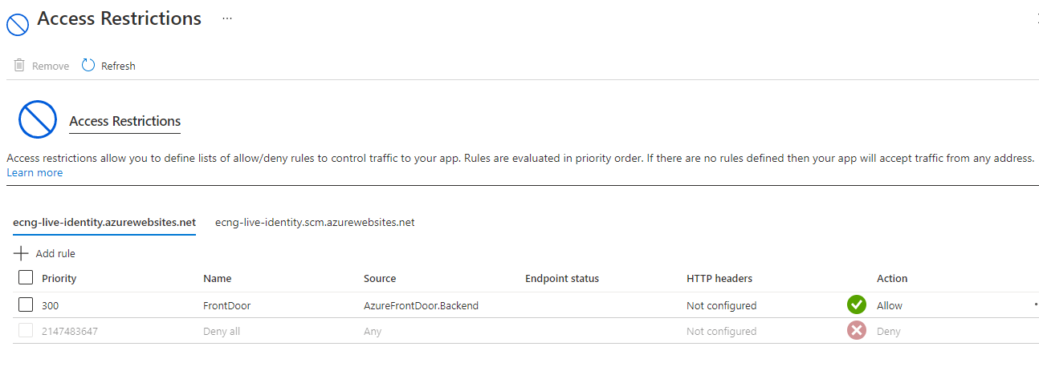

### Access restriction for database server

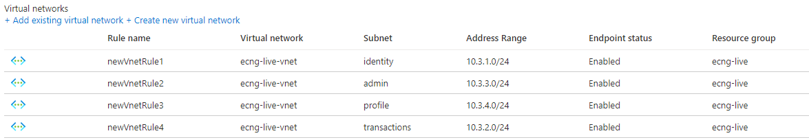

### Access restriction for **storage account**

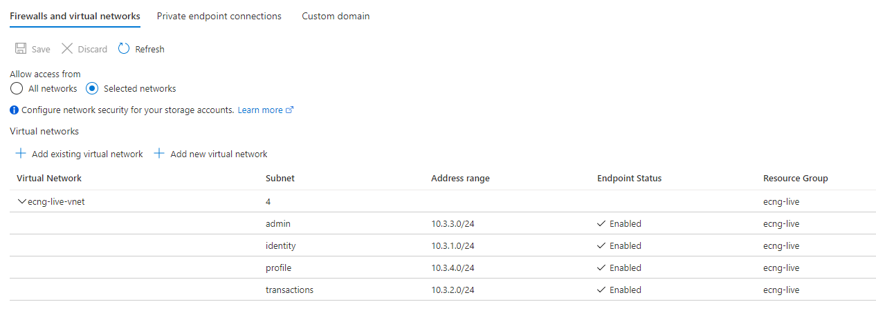

### Subnets and services delegation

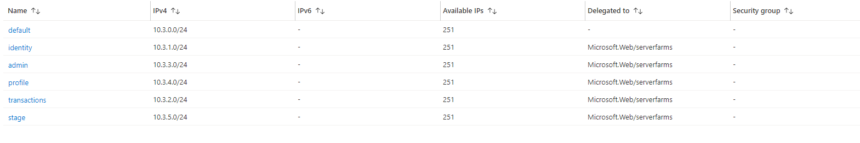

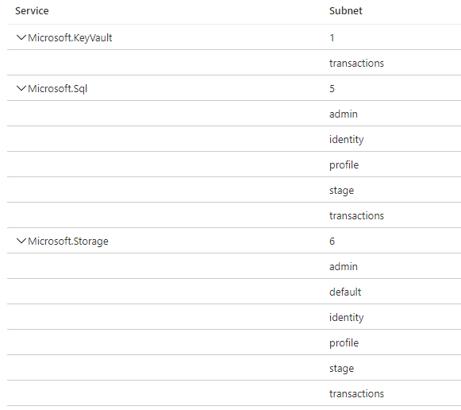

### App services subnets usage

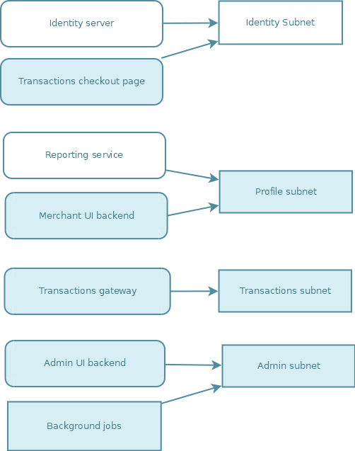

### Front Door and WAF

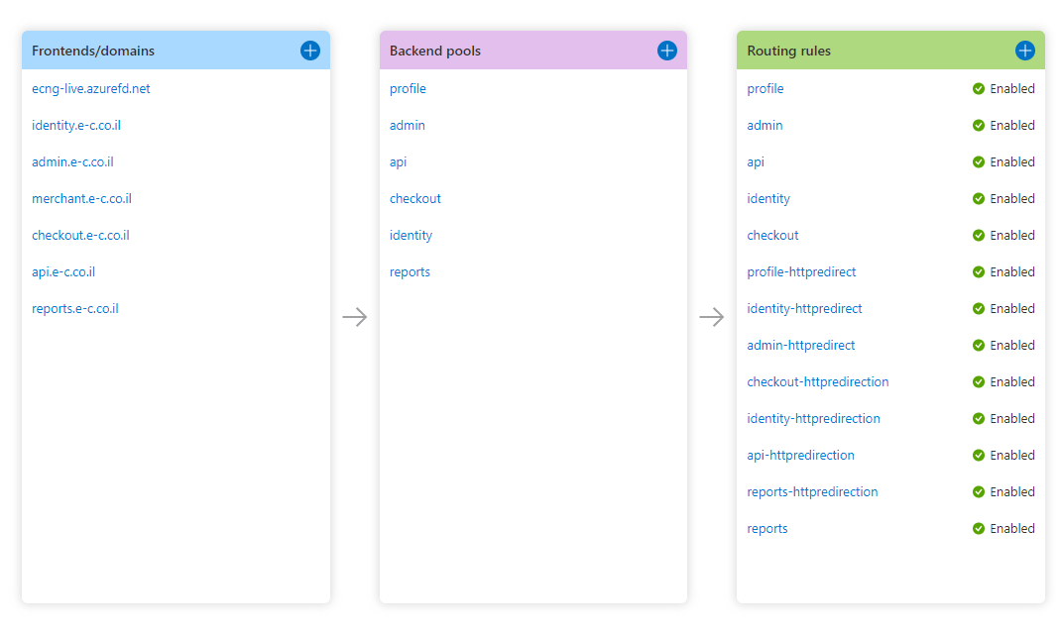

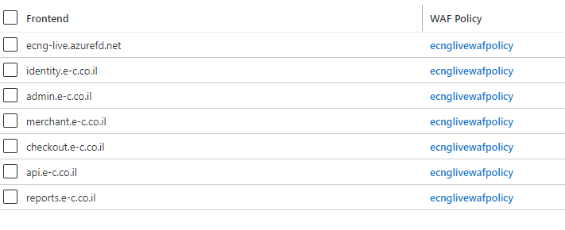

### WAF policy 2.3

For the moment WAF used standard set of MS protection rules (aka Managed Rules) – see "EasyCard - List of enabled standard WAF rules.docx"

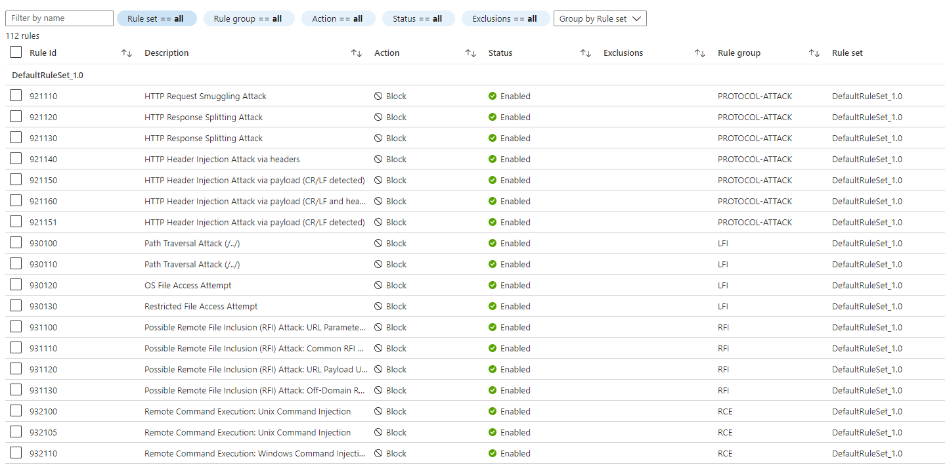

### Closed ports 2.3b

